Group |  | Topic and Author
Drives, Simatic-NET |  | Sinamics S120 Control with a PC Station as a OPC Server
 |  | Raj Rajendra

Overview

- You have a need to control and monitor a Sinamics S120 drive with a PC application like VB, Excel etc. Here all you have is a drive, a PC with a Profibus card. The PC functions as your OPC server accessing the tags in drive representing the Start/Stop commands, Speed Setpoints, Speed Actual values and drive status. Your application ( VB, Excel etc. ) will access the OPC tags to do the control and monitoring. You don’t need any HMI software to do this and you will custom design your HMI application.
- Not everyone will use a PLC to connect the drive to do the control and monitoring. This is an easier and cheaper way to control and monitor with just the Starter software to configure the drive, Step-7 to configure the PC station and it’s connections to the drive on Profibus and an application tool like VB to build your HMI application.
- Additionally you will be able to run your HMI application on a remote PC that is connected to your PC station via Ethernet so that you can do the control and monitoring from a remote PC.
- With the addition of motion profiles to the Sinamics drives you will be able to control and monitor the motion profiles in the drive without a PLC or a dedicated HMI.

STEP By STEP
The basic steps in setting up and verifying the application note are outlined below.
- Setup a S7 project with Step-7
- Configure the Sinamics S120
- Configure the drive Command, Setpoint and Status words for OPC access
- Create OPC tags with Simatic NET Configuration Console
- Testing the OPC tags with Simatic NET OPC SCOUT
- A VB Application using these OPC tags

STEP 1 – Setup a S7 project with Step-7

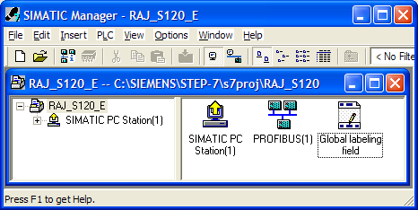
Our project is going to consist of a PC station i.e. your PC with a Profibus card ( in this case a PCMCA CP5512 card ) and Sinamics S120 drive system connected to the Profibus network.

In our hardware configuration for the PC station we will have the CP5512 in slot 1 and OPC Server application configured in slot 2 of the PC station as shown below.

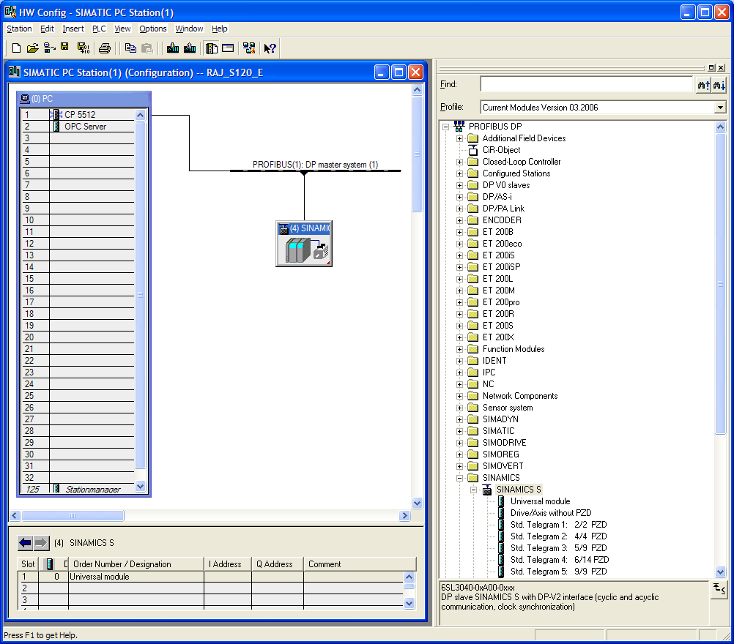
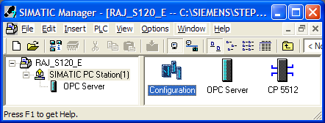

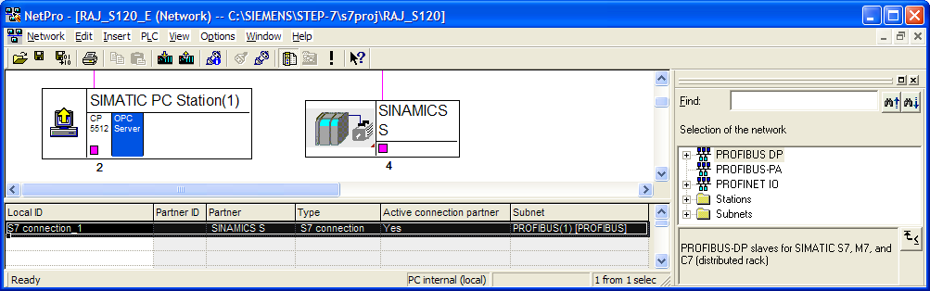
You will have the Sinamics S120 configured as a slave ( with address 4 in this example ). You will configure drive slot 0 with a Universal module with no I Address or Q Address assigned. The 2-axis S120 Demo Unit is used in this exercise.

Next you will start Netpro to configure the connections to the drive and the PC station. The connection information is shown below.
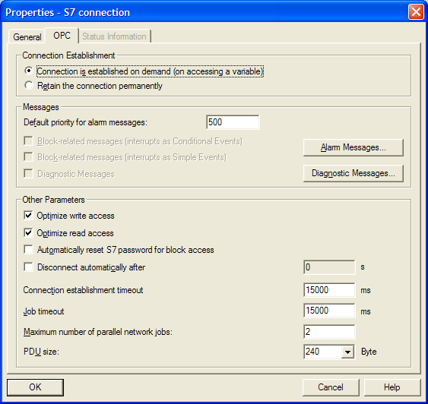
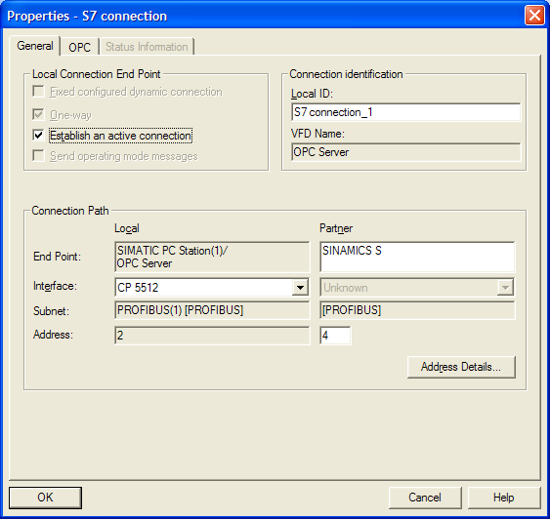

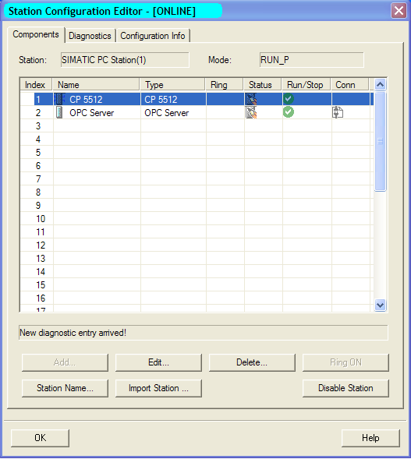
This completes the setting of the Step-7 project. You will download this configuration to your PC station. Make sure you download the connections and gateways from Netpro after you have downloaded the hardware from the hardware configurator. Or you can do the full station download from Netpro itself.
After the download open the PC station and verify that the OPC server is running healthy.

STEP 2 – Configure the Sinamics S120 with Starter
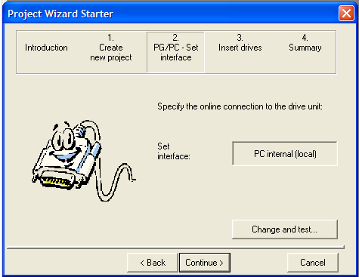
You will use Starter to configure the drive. You can do this by starting Starter from the computers Start menu. Use the project wizard to create your project.

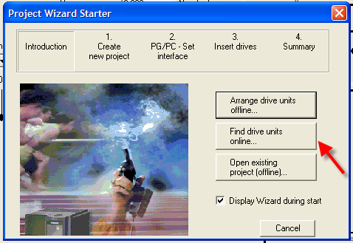

Click on find drive units online button.
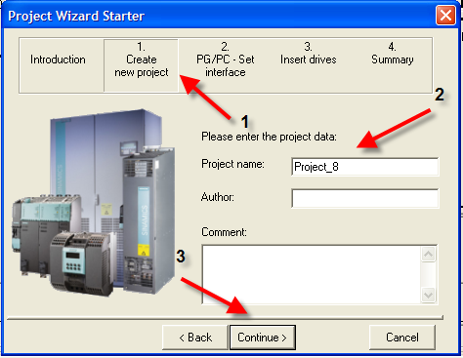

In the Create new project [1] section give a name to your project [2] and click the continue button [3].

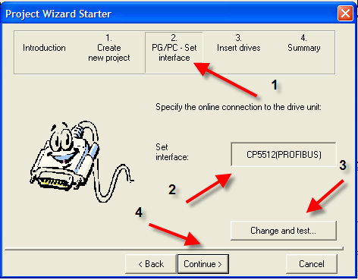

In the PG/PC - Set interface section [2] make sure your interface is set to the CP card you are using ( here it is a CP5512 ) [2] or else go and change to the right interface with the ‘Change and test’ button [3]. Then press the continue button [4].

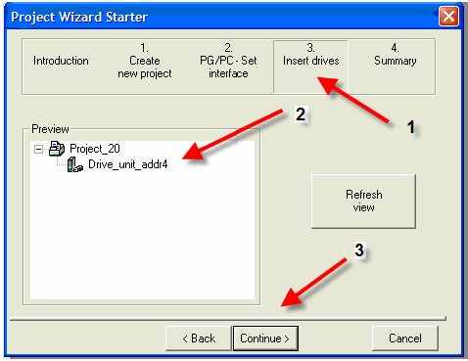
In the next ‘Insert drives’ section [1] you will find that it has and detected the drive with the Profibus address of 4 [2]. Press the ‘Continue’ button [3].

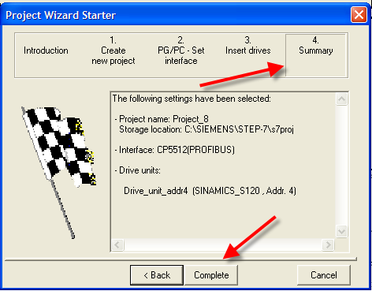
Under the Summary tab it gives the summary of its online finding as shown here. Press the ‘Complete’ button to finish the wizard project creation process.

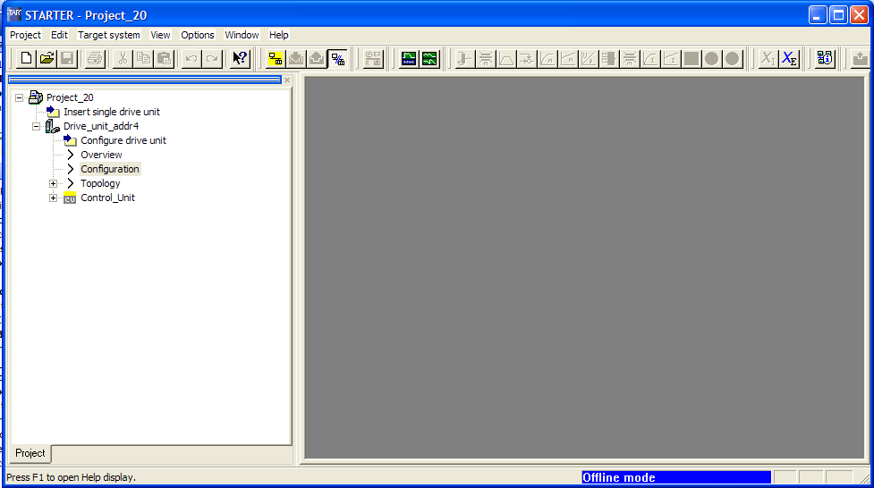
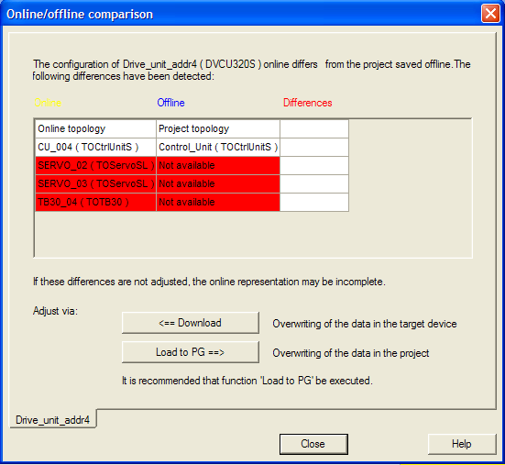
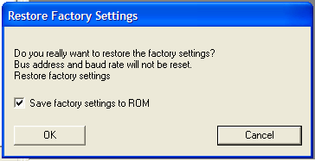
To start with a clean slate we will go online and select the drive unit and right-click on it to choose restore factory settings. In this way any left-over configuration in the drive will be deleted and we will have all the default settings. When you go online you will get a warning about differences between online and offline configurations. Just ignore them and continue to go online so that you can set the drive to factory settings. Press OK in the warning box about restoring factory settings.

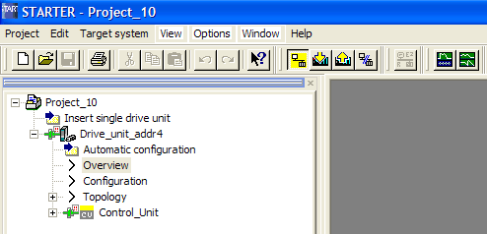

The next step is to automatically configure the drives attached to the control unit in our project.

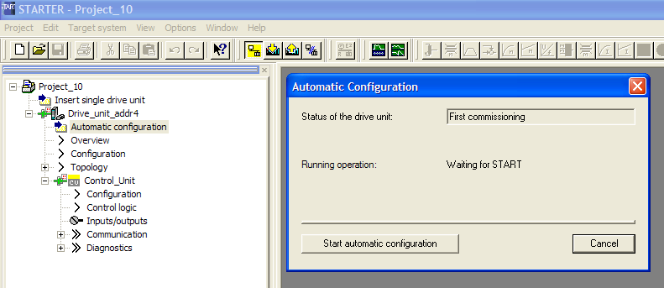
In order to do this, double-click on ‘Automatic configuration’ under the Drive_unit_addr4 menu. Here you will click on ‘Start automatic configuration’ button.

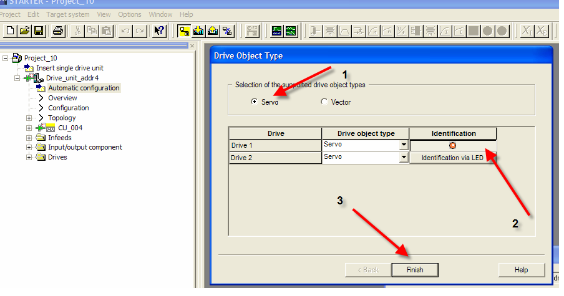
Starter will go ahead and configure the drives automatically based on the information it can retrieve from Drive-CLiQ. The drives/components that aren’t on Drive-CLiQ will have to be configured manually. Make sure you have selected servo drives [1]. The drives identified can be detected by clicking on the identification button and you will notice the LED on the drive flashing when you do this. Complete this process by clicking on the ‘Finish’ button.
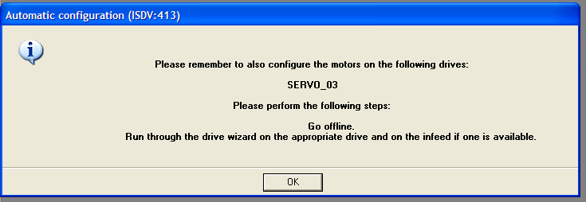
Next you get a warning that Servo_03 has to be manually configured. This drive is not Drive-CLiQ all the way through to the motor it is controlling. The auto configurator could not figure out what was attached to the drive. In order to do this we will go offline and select Servo_03 and open the configuration menu for it. The configuration is started by clicking on the ‘Configure DDS’ button.
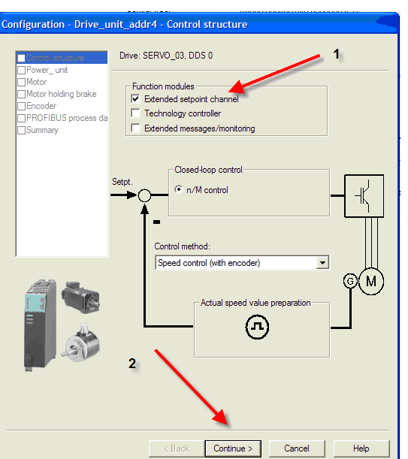
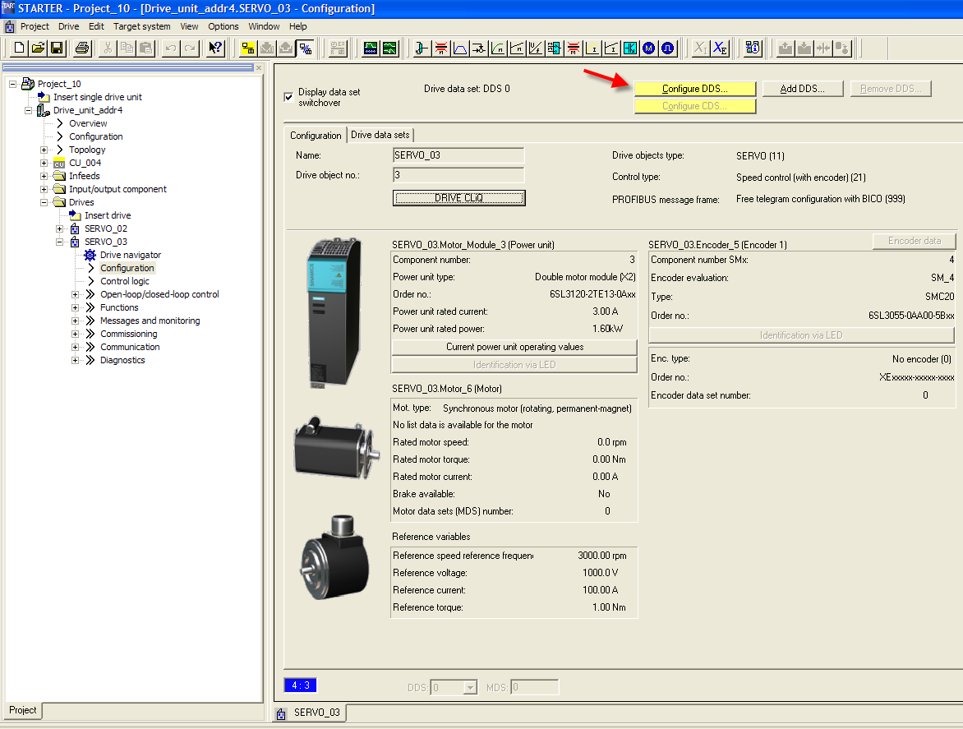
In the first window for ‘Control Structure’make sure you have selected the extended setpoint channel option [1] and then press continue.

In the next window titled ‘Power Unit’ select the right motor module that is used in your drive system [1].
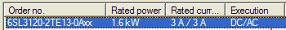
In our case it is . Next click on ‘Continue’ to go to the next step. You will get a warning message and you click on the ‘OK’ button on this window and click on continue [2].
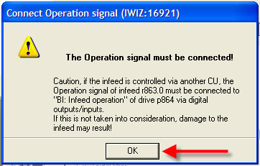
The warning message window is shown here.

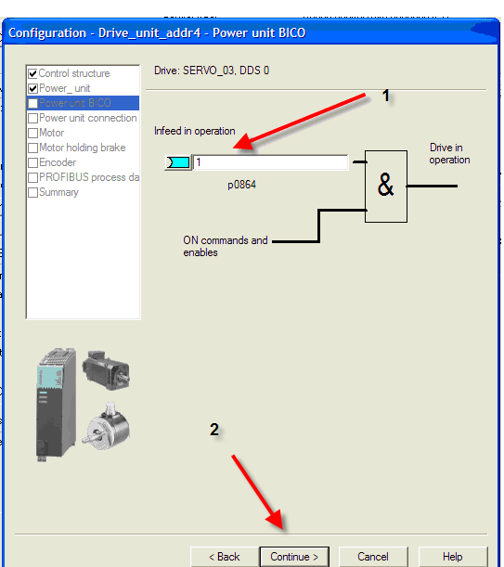
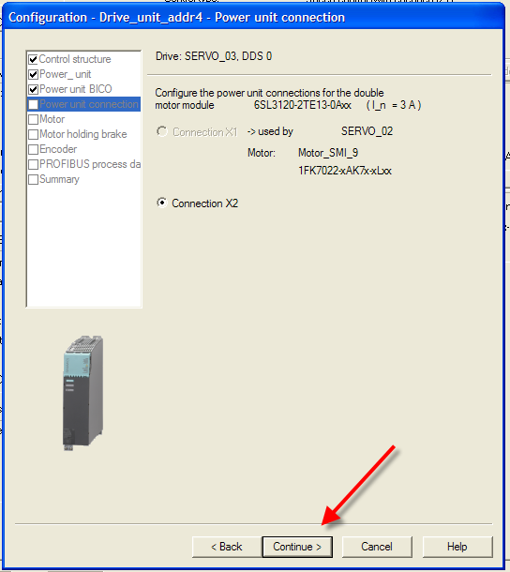
The next step is to define the ‘Power Unit BICO’ connection. Here you will select ‘Infeed in operation’ has an entry of ‘1’ . It gets ANDed with ON command for the drive to start the drive. Click on next to continue.

The next step is to define the ‘Power Unit Connection’ . Here there is only one choice and you will see that it is already selected by the system. Press the ‘Continue’ button to go to the next step.

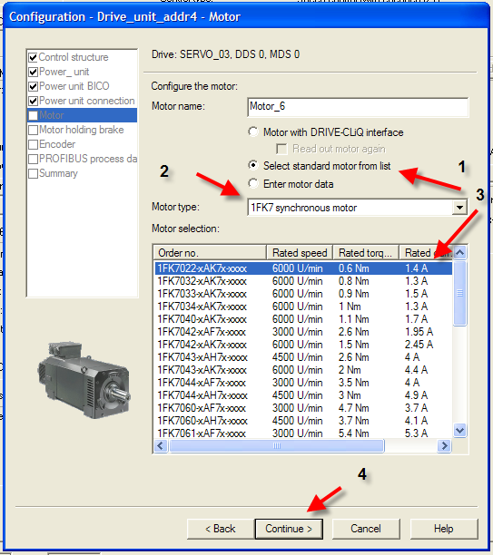
In the next step you specify the motor that is controlled by the drive. Here you will choose ‘Select standard motor from list’ [1], ‘Motor Type’ of 1FK7 Synchronous Motor [2], and the ‘Motor selection’ 1FK022-xAK7x-xxx [3]. Click on ‘Continue’ [4] to go to the next step.
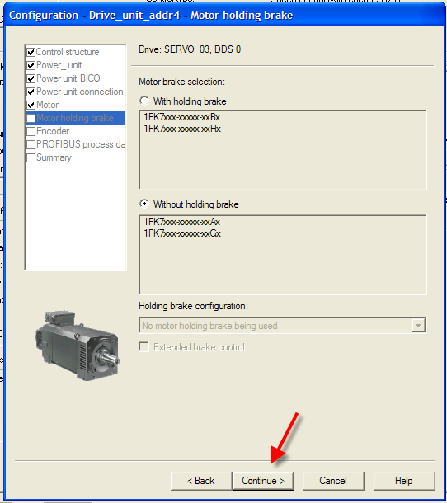

The next step is about ‘Motor holding brake’ and since there is none just click on the continue button.

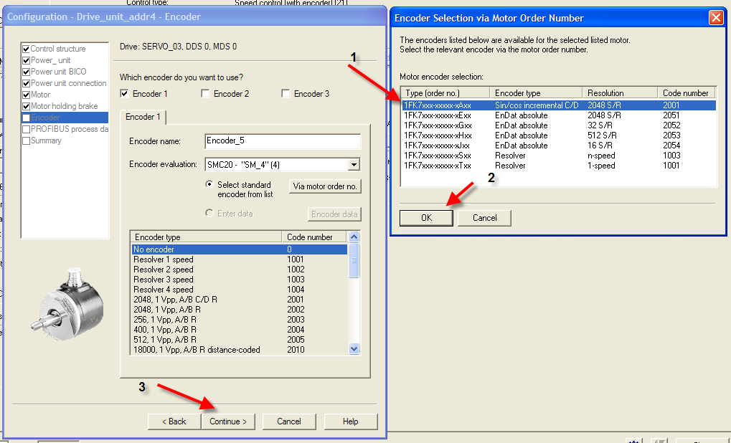
In the next step you will specify the encoder by clicking on this button . When you do this the pop-up window will show the possible encoders and you will pick 1FK7 Sin/Cos Incremental encoder and click on the OK button.
In the next window click on the ‘Continue’ button.

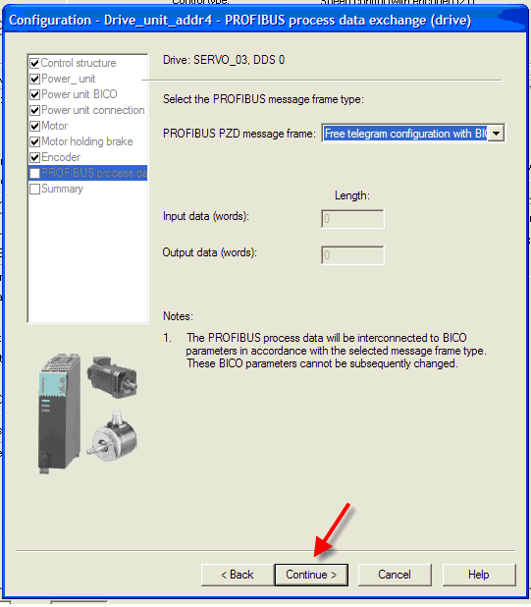

In the next step we will specify what type of Profibus PZD message frame we will be using. Here we will choose 'Free telegram configuration with BICO'. Click on ‘Continue’ to go to the next step.

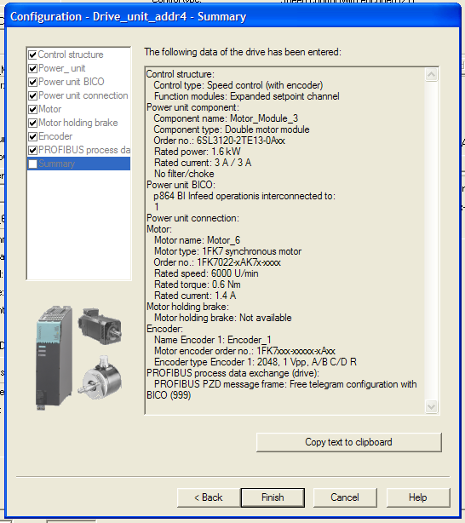
The next step shows the summary of your selections. You will click on the ‘Finish’ button to complete the configuration of Servo_03.

You will save your project and download the settings to the drive.

STEP 3 – Configure the drive Command, Setpoint and Status words for OPC access

In Starter go offline and open Servo_02 Configuration and click on ‘Configure DDS’.

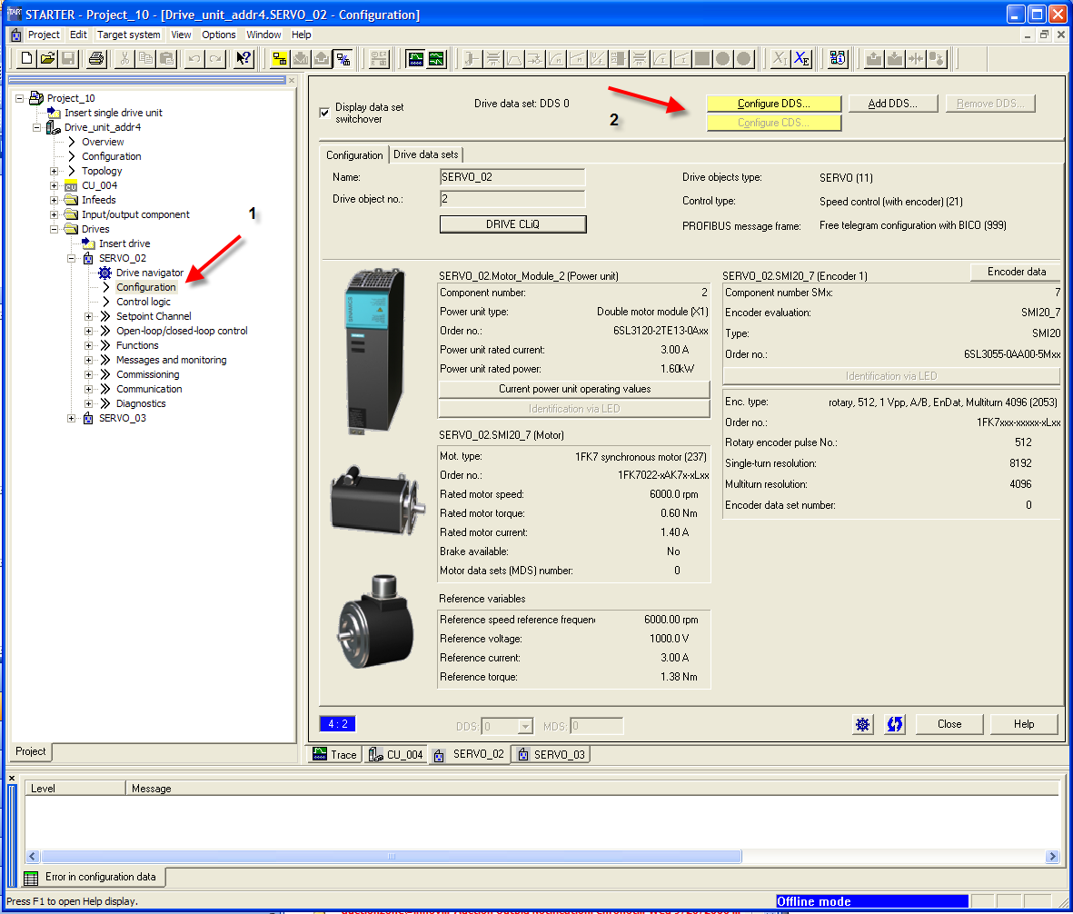

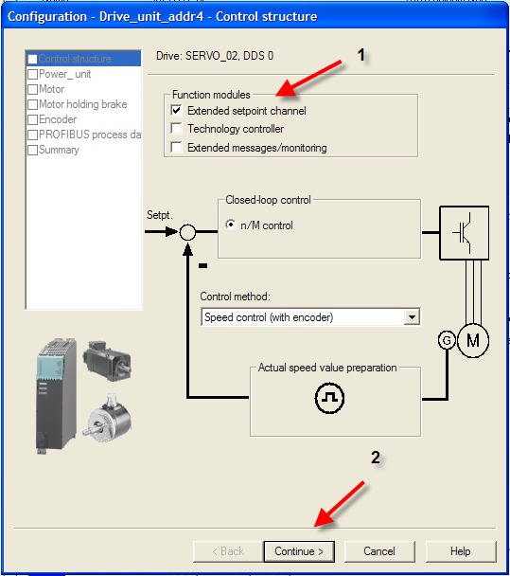
Make sure under ‘Control structure’ ‘Extended setpoint channel’ is selected for Servo_02 as shown here. You may continue with the rest of the setup without any changes until you are done.

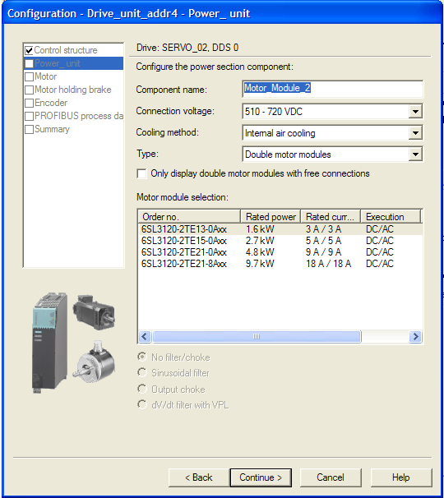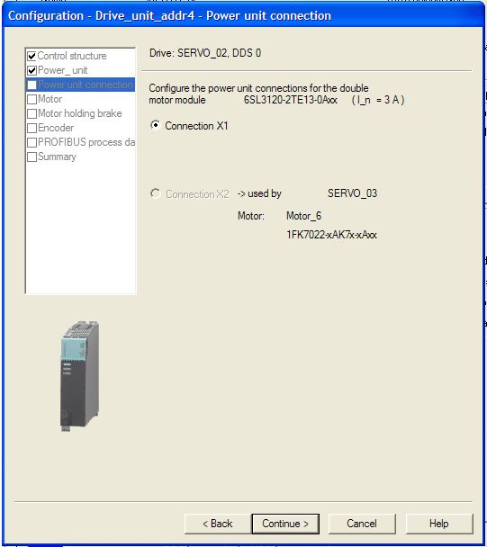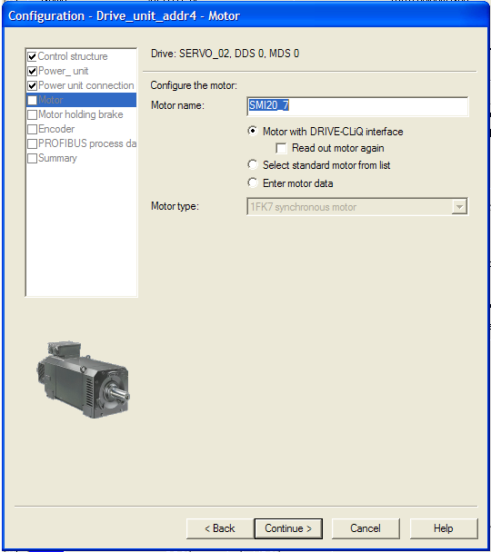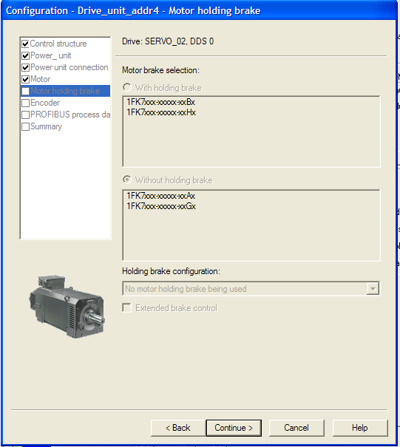
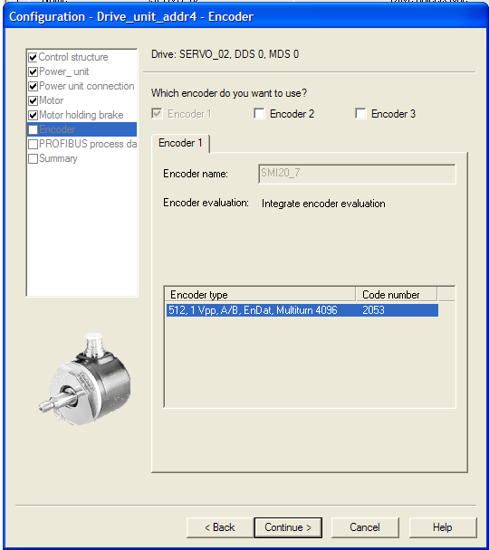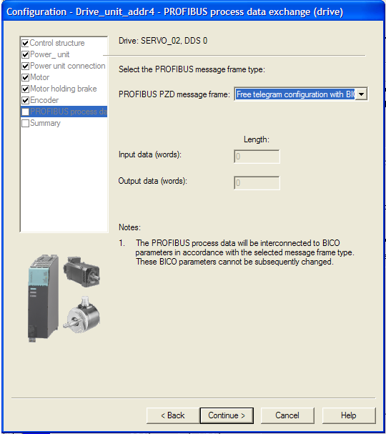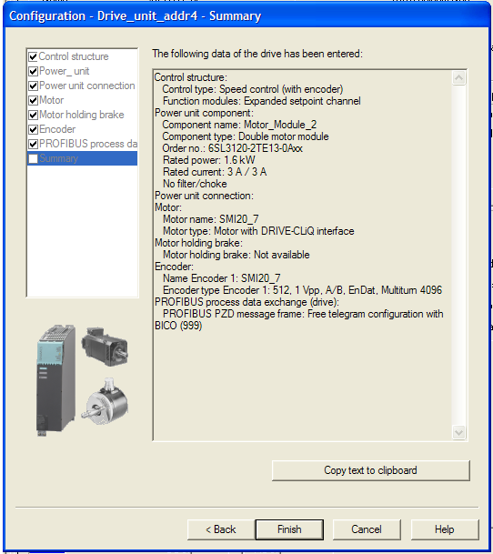

Go online and download the configuration to your drive.

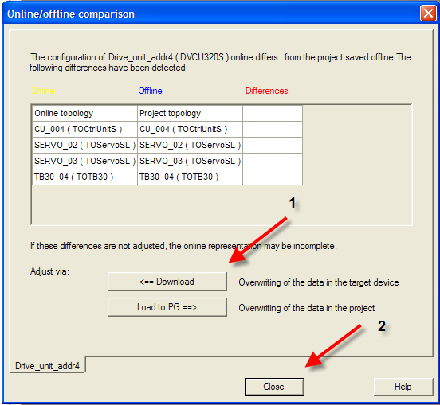

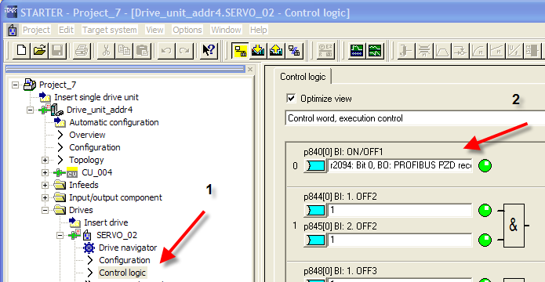
Open Servo_02 ‘Configuration and assign Control Word, execution control Bit 0 i.e. p840[0] BI which is ON/OFF1 to r2094 bit 0 BO of Servo_02. In effect we are assigning the bit received from the PZD on Profibus to the drive control. This gets mapped as tag DB2098.DBW2048 data type INTEGER for our OPC purposes.

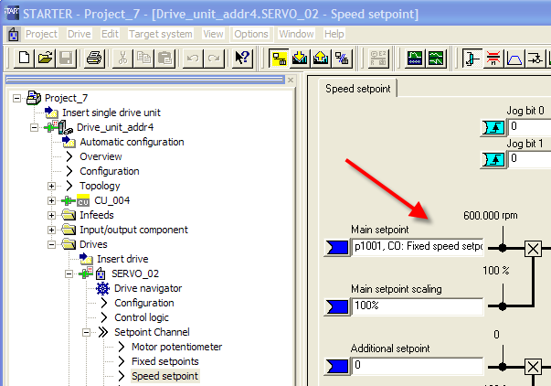
Open ‘Speed set point’ for Servo_02 and assign Main setpoint to P1001, CO: Fixed speed setpoint. This gets mapped as tag DB1001.DBD2048 data type ‘REAL’ for our OPC purposes.

The status word for drives ( r898 data type WORD ) is mapped as DB898.DBW2048 data type WORD and you don’t have to do any special setup in the drive for this.
The actual speed of the drive ( r63 data type REAL ) is mapped as DB63.DBD2048 data type REAL.
You will do the same thing for Servo_03 and the data mapping is in the same data blocks for each parameter type with an offset of 3072 ( instead of 2048 which was for Servo_02 ).

Here is the summary of tags:

Command/Setpoint/Status | Servo_02 | Servo_03 | Data Type
ON/OFF1 | DB2098.DBW2048 | DB2098.DBW3072 | INTEGER
SETPOINT | DB1001.DBD2048 | DB1001.DBD3072 | REAL
STATUS | DB898.DBW2048 | DB898.DBW3072 | WORD
ACTUAL SPEED | DB63.DBD2048 | DB63.DBD3072 | REAL

STEP 4 – Create OPC tags with Simatic NET Configuration Console
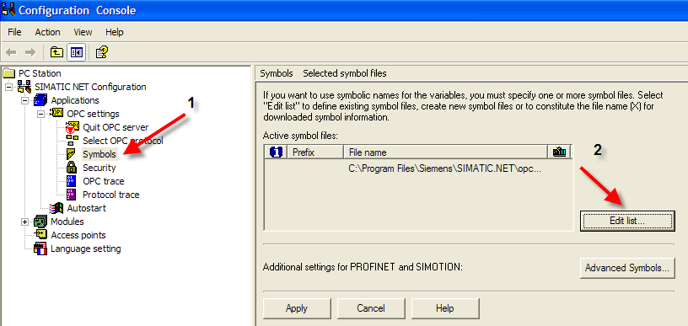
Open the Configuration Console select symbols [1] and click on ‘Edit list’ [2].

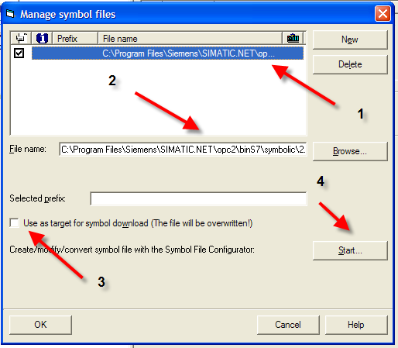

In the “Manage symbol files’ window that follows it will show you the symbol file name it is going to use to store the symbols you define [1]. You can choose another file name by clicking on the ‘Browse’ button [2]. Also make sure you have not selected the ‘Use as target for symbol download’ option [3]. Otherwise your project symbols will be overwritten with the symbols you define in the file you choose. Next click on the ‘Start’ button [4].
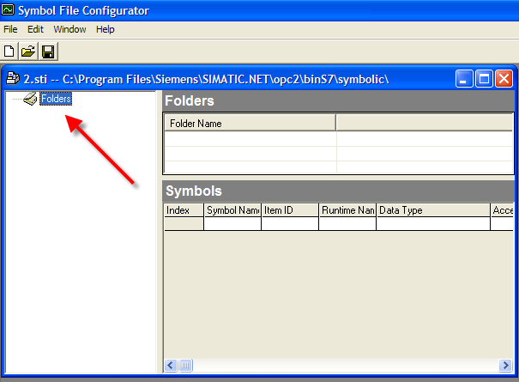
In the ‘Symbol File Configurator’ window that follows click on the ‘Folders’ of the symbol file you have chosen and ‘Right Click’ on it. With this you will have an option to add ‘New items’ and you will choose this to define the new symbols.

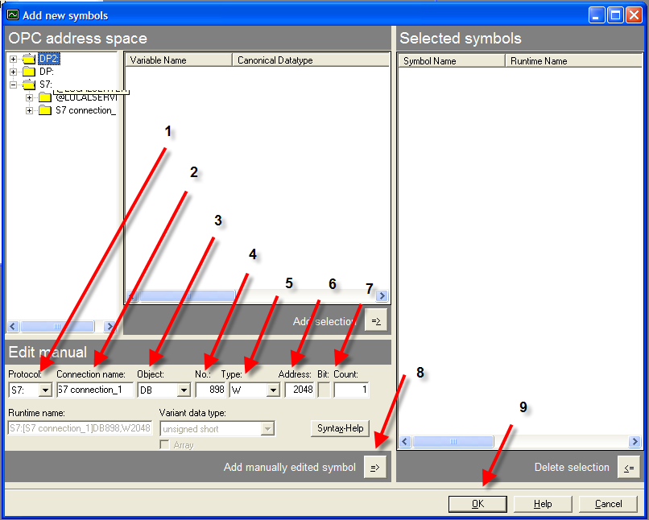
In the ‘Add new symbols’ window under ‘Edit manual’ you will select your ‘Protocol’ as ‘S7’ [1], ‘Connection name’ as the S7 connection name you gave in Netpro for the connection between your PC Station and the S120 drive which is ‘S7 connection_1’ [2], ‘Object’ as DB [ 4] and the rest according to the tag requirement s as defined in the earlier section i.e. DB No [4], Data ‘Type’ [5], ‘Address’ [6], and ‘Count [7]. Once you enter a tag you will click on the ‘Add manually edited symbol’ button 8]. Once all the tags are entered you will click on the ‘OK’ button to exit the ‘Add new symbols’ section.

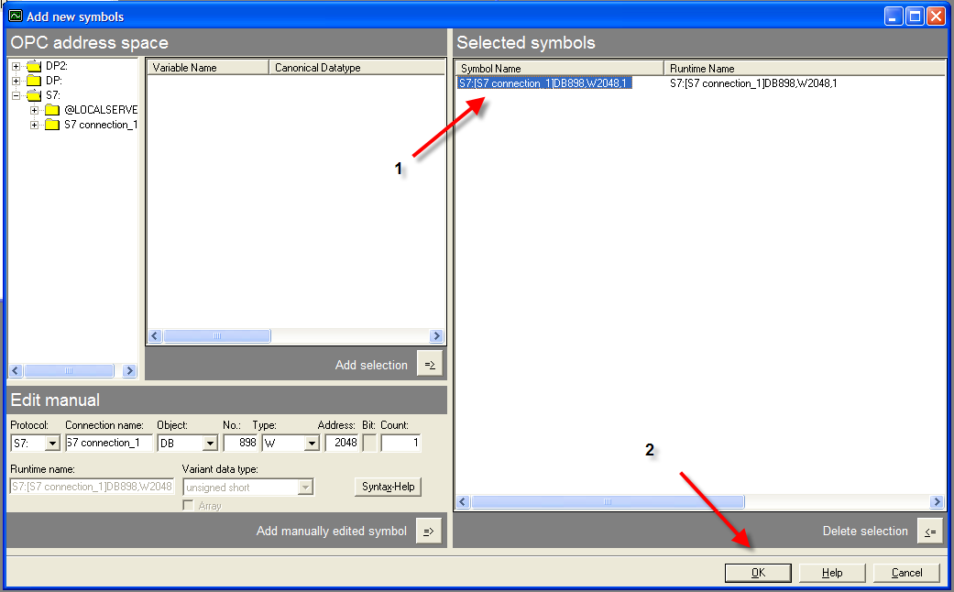
All the symbols you have added will be shown under ‘Selected symbols’ in the ‘Add new symbols’ window [1] and you will exit this section by clicking on the ‘OK’ button [2].

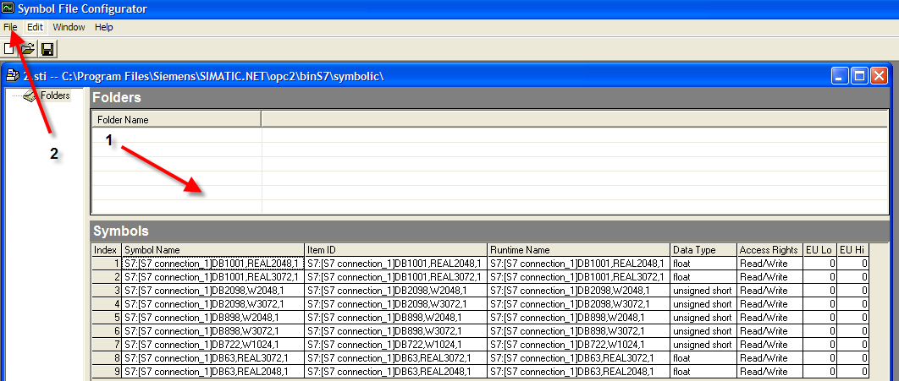
Now you can view all the tags you have defined in ‘Symbol File Configurator’ under the ‘Folders’ [1]. With this you will save your symbol file using the ‘File’ drop-down menu [2] and exiting from here.

STEP 5 – Testing the OPC tags with Simatic NET OPC SCOUT

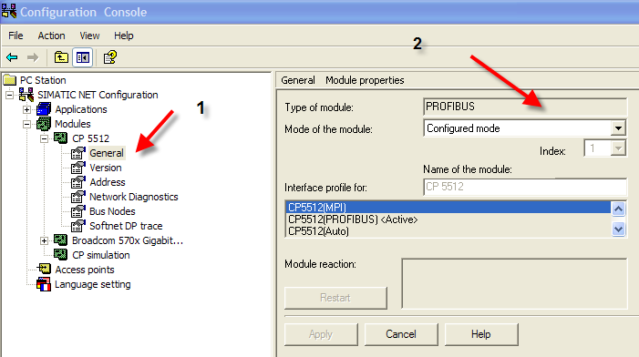
First make sure you have selected the Profibus CP module on your PC ( here it is a CP5512 ) is selected to be in ‘Configured mode’ in the Configuration Console.

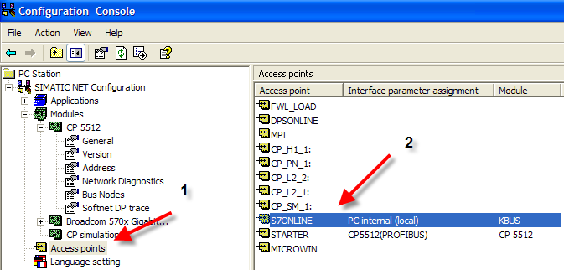

Also you will ensure under ‘Access points’ [1] S7ONLINE is assigned to PC online ( local ) [2].

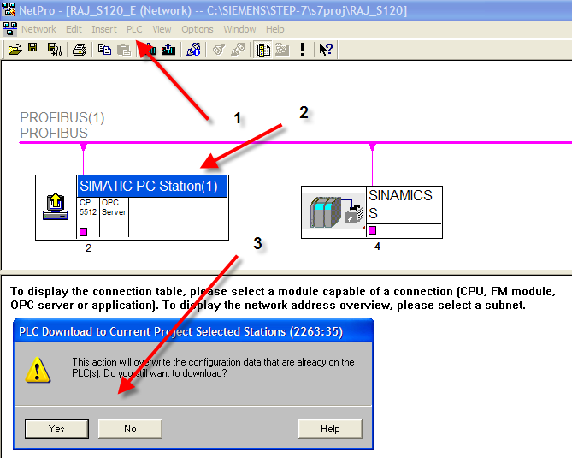
In Netpro under the PLC drop-down menu [1] choose to download selected station ( after clicking on the PC Station [2] ) and select ‘Yes’ on the pop-up window [3].

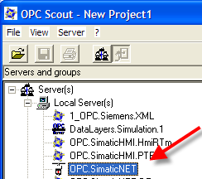

Open Simatic NET OPC SCOUT and select OPC.SimaticNET and right-click and choose the ‘Connect’ option.

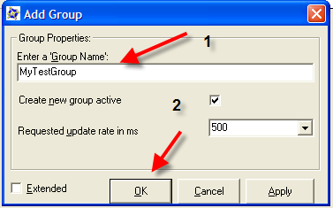
In the next pop-up window ‘Add Group’ when you are prompted for ‘Group Name’ [1] type in a name of your choice and click on ‘OK’ [2].
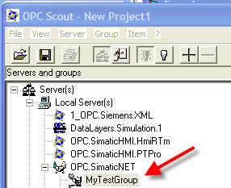

Right click on the item you have added and select ‘Add Item’.

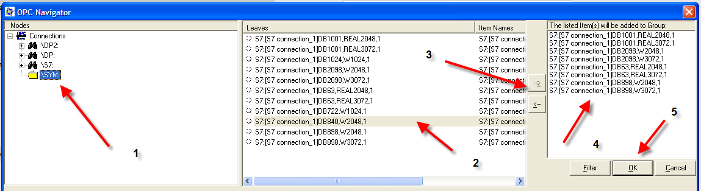
In the ‘OPC-Navigator’ window select the ‘SYM’ folder [1] and from the middle column of symbols [2] choose the tags you want to monitor and control [2] and move them to the right most column by clicking on the ‘->’ button [3] and the selected symbols will appear in the right most column [4]. Then click on the ‘OK’ button [5].

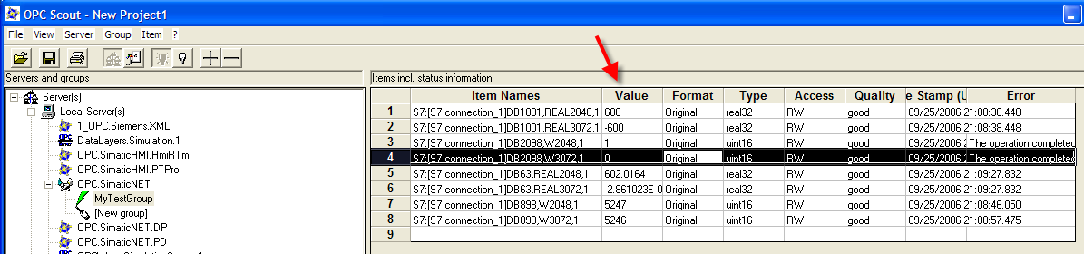
You will be in the OPC SCOUT monitoring mode now. Here you can choose a tag and by double clicking in the Value column you can enter the tag values for tags you want to write. In our case the first two rows are tags for the setpoint values of Servo_02 and Servo_03. Rows 3 & 4 contain the start /stop commands for the two servos. By entering a floating point number for setpoint and entering a ‘1’ or ‘0’ for the start/stop tag you will be able to exercise the drives. You can get out of the OPC SCOUT now.

STEP 6 – A VB Application using these OPC tags

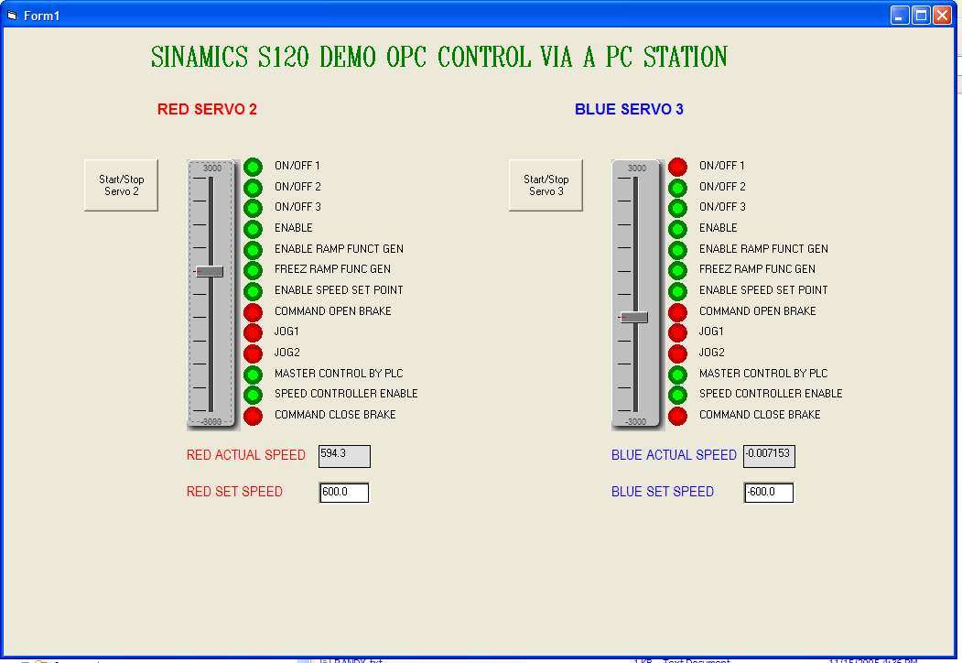
The HMI interface shown here is developed with VB and the OPC tags we have created.
The Start/Stop buttons are used to Start and stop the servos. The slider bar or data entry field allows setting of speed. The RED/GREEN circles animate the status of the drive. In this case the left drive is in run mode. The actual speed is also displayed below the slide bar.
You will need the OPC Server provided by Simatic NET to attach the OPC tags to your data display/entry objects’ appropriate value fields.

This is not an exercise in VB programming. I am enclosing the source for the interested to explore the programming side of it.

Related Information

Spring Training 2006 Notes by Carl Owens:
Sinamics Commissioning ( PowerPoint )
Note: This uses SIMOTION Scout software for the drive commissioning. The appnote has used Starter which has subtle differences.
HMI Lab ( MS Word )

Hardware and Software Considerations

Item | MLFB | Notes
CP5512 | 6GK1551-2AA00
Siamics S120 | 2-Axis Demo System | Firmware version1.42
Step-7 |  | V 5.4
Simatic NET PC Software |  | V 6.3 + HF1
MS Visual Basic |  | V 6.0
Starter |  | V 4.0

General Notes

The SIMATIC Application Tips are provided to give users of Siemens’ Simatic products some indication as to how, from the view of programming technique, certain tasks can be solved. These instructions do not purport to cover all details or variations in equipment, nor do they provide for every possible contingency. Use of the Simatic Application Tips is free.

Siemens reserves the right to make changes in specifications shown herein or make improvements at any time without notice or obligation. It does not relieve the user of responsibility to use sound practices in application, installation, operation, and maintenance of the equipment purchased. Should a conflict arise between the general information contained in this publication, the contents of drawings or supplementary material, or both, the latter shall take precedence.

Siemens is not liable, for whatever legal reason, for damages or personal injury resulting from the use of the application tips.

All rights reserved. Any form of duplication or distribution, including excerpts, is only permitted with express authorization by SIEMENS.

